Front End Engineering-II

Project Report Semester-IV (Batch-2022)

**SUMMER EXPLORING WEBSITE**



|  |  |
| --- | --- |
| **Supervised By:**  **Dr. Anjali** | **Submitted By:**  **Shivam Mainro 2210990825(G-12)** |

**Department of Computer Science and Engineering Chitkara University Institute of Engineering & Technology**

**Chitkara University, Punjab**

**INDEX**

|  |  |  |
| --- | --- | --- |
| **S.No.** | **Title** | **Page Number(s)** |
| 1 | Introduction | 3-6 |
| 2 | Problem Statement | 6-8 |
| 3 | Requirements | 9 |
| 4 | Proposed Design | 10 |
| 5 | File Structure | 11-15 |
| 6 | Results | 16-20 |
| 7 | References | 21 |

# Abstract

# This React application is a website for a restaurant, designed across multiple pages.

# This React-based website showcases a modern restaurant's online presence. The application comprises several pages, each serving distinct purposes.

# Home

# Features a navigation bar for easy access to different sections.

# Promotes the restaurant's unique offerings with enticing visuals and persuasive copy.

# Provides a call-to-action button prompting users to explore the menu.

# About

# Introduces the restaurant's story and ethos.

# Highlights the ambiance and culinary experience through captivating imagery and compelling text.

# Menu

# Displays a selection of dishes offered by the restaurant, accompanied by enticing descriptions.

# Invites users to explore the diverse menu options.

# Reservation

# Facilitates the booking process for diners.

# Allows users to specify the number of guests, desired date, and time for their reservation.

# Chefs

# Showcases the talented culinary team behind the restaurant's creations.

# Provides insights into each chef's background and expertise.

# News

# Presents the latest updates and news related to the restaurant, including featured recipes and culinary tips.

# Footer

# Includes essential contact information and social media links.

# Offers quick navigation options to different sections of the website.

# Overall, the website aims to engage users with its visually appealing design, informative content, and seamless navigation, enhancing their online dining experience and encouraging them to visit the restaurant in person.

# Top of Form

# Introduction

# Welcome to our restaurant's official website, a digital gateway to a world of culinary delight and exceptional dining experiences. Designed with React, this website offers an immersive journey through the various facets of our restaurant. From the welcoming ambiance to the delicious menu, and the talented chefs behind the scenes, every page is crafted to provide a glimpse into what makes our establishment unique. Whether you're looking to make a reservation, learn more about our dishes, or stay updated with our latest news, our website is your one-stop destination for all things related to our restaurant. Join us in discovering a new level of taste and hospitality

# Background

In an era where online presence is crucial for businesses, our restaurant sought to create an engaging and informative website that reflects the quality and uniqueness of our dining experience. Leveraging React, a powerful JavaScript library for building user interfaces, we developed a dynamic and responsive website. This digital platform not only showcases our diverse menu and talented culinary team but also provides users with a seamless way to make reservations and stay updated with the latest news and events. Our goal is to offer a comprehensive online experience that mirrors the excellence and hospitality of our physical restaurant, inviting patrons to explore and connect with us even before they step through our doors.

# Objective

The primary objective of our React-based restaurant website is to enhance the online presence of our establishment and provide users with a compelling and informative platform. Through intuitive navigation and visually appealing design, we aim to:

* Showcase the unique ambiance, cuisine, and offerings of our restaurant.
* Engage users with enticing visuals, persuasive copy, and seamless user experience.
* Facilitate the reservation process, allowing users to book tables conveniently.
* Highlight the expertise and talent of our culinary team.
* Keep patrons informed and engaged with the latest news, updates, and events. By achieving these objectives, we aspire to attract more customers, foster loyalty, and create memorable dining experiences both online and offline.

.

# Significance

Our React-based restaurant website holds significant value in several ways:

* Enhanced Visibility: By establishing a strong online presence, we reach a broader audience beyond our physical location, increasing brand visibility and attracting potential customers.
* Improved Customer Experience: The user-friendly interface and intuitive navigation enhance the overall customer experience, making it easier for users to explore our menu, make reservations, and stay updated with our offerings.
* Competitive Edge: In a competitive industry, a well-designed website sets us apart from competitors, showcasing our unique features, culinary expertise, and commitment to customer satisfaction.
* Effective Communication: The website serves as a communication channel, allowing us to share important updates, promotions, and news with our audience, fostering engagement and loyalty.
* Business Growth: By leveraging digital platforms like React, we can drive business growth, increase customer engagement, and ultimately, boost revenue and profitability. In summary, our restaurant website is not only a digital representation of our brand but also a powerful tool for attracting, engaging, and retaining customers in today's digital landscape.

# Problem Definition

Prior to developing our React-based restaurant website, our establishment faced several challenges:

* Limited Online Presence: Without a dedicated digital platform, we struggled to reach potential customers beyond our physical location, hindering our ability to attract a wider audience.
* Inefficient Reservation Process: The lack of an online booking system made it cumbersome for customers to reserve tables, resulting in potential loss of business and dissatisfaction among patrons.
* Poor Engagement: Without a centralized platform for sharing updates and engaging with customers, we struggled to maintain communication and foster loyalty among our audience.
* Competitive Disadvantage: In an increasingly digital world, the absence of a modern and user-friendly website put us at a disadvantage compared to competitors who leveraged digital platforms effectively. By defining these problems, we recognized the need for a robust and interactive website to address these challenges and enhance our online presence, customer engagement, and overall competitiveness.

# Requirements:

# To address the identified problems and achieve our objectives effectively, our React-based restaurant website must fulfill the following key requirements:

# User-Friendly Interface: The website should have an intuitive and visually appealing interface, allowing users to navigate effortlessly and find relevant information such as menu options, reservations, and news updates.

# Online Reservation System: Implement a seamless online booking system that enables customers to reserve tables conveniently, select preferred dates and times, and receive confirmation emails.

# Menu Showcase: Display a comprehensive and visually engaging menu showcasing our diverse range of dishes, complete with descriptions, prices, and images to entice customers.

# Chef Profiles: Highlight the expertise and backgrounds of our culinary team through informative chef profiles, fostering trust and confidence in our restaurant's quality.

# News and Updates Section: Provide a dedicated section for sharing news, promotions, events, and culinary tips to keep customers informed and engaged.

# Responsive Design: Ensure that the website is fully responsive and compatible across various devices and screen sizes, providing a consistent user experience regardless of the platform used.

# Search Engine Optimization (SEO): Implement SEO best practices to enhance visibility and ranking on search engine results pages (SERPs), increasing organic traffic and attracting more potential customers.

# Integration with Social Media: Enable seamless integration with social media platforms to encourage user engagement, sharing, and promotion of our restaurant's offerings.

# By meeting these requirements, our React-based website will effectively address the identified challenges, enhance our online presence, and provide customers with a seamless and engaging digital experience.

# Proposed Design

# Our proposed design for the React-based restaurant website emphasizes simplicity, elegance, and functionality to deliver an exceptional user experience. Here's an overview:

# Homepage:

# Clean layout with captivating imagery and concise copy introducing our restaurant's unique offerings.

# Clear navigation menu providing easy access to different sections of the website.

# Menu Section:

# Visually appealing showcase of our menu items, organized into categories for easy browsing.

# Each menu item accompanied by enticing descriptions, prices, and high-quality images to entice customers.

# Reservation System:

# Seamless online booking system integrated into the website, allowing customers to reserve tables with ease.

# Intuitive interface enabling users to select preferred dates, times, and party sizes, with instant confirmation.

# Chef Profiles:

# Dedicated section highlighting the expertise and backgrounds of our culinary team.

# Informative profiles featuring photos, bios, and accomplishments to build trust and credibility.

# News and Updates:

# Dynamic section showcasing the latest news, promotions, and events related to our restaurant.

# Engaging content such as featured recipes, chef interviews, and culinary tips to keep customers informed and entertained.

# Responsive Design:

# Fully responsive layout optimized for seamless viewing and interaction across desktops, tablets, and smartphones.

# Consistent branding and design elements ensure a cohesive experience across all devices.

# SEO Optimization:

# Implementation of SEO best practices to improve visibility and search engine ranking, attracting more organic traffic to the website.

# Social Media Integration:

# Integration with popular social media platforms to encourage user engagement, sharing, and community building.

# Social media buttons and widgets strategically placed throughout the website for easy access.

# By incorporating these design elements and features, our proposed design aims to create a compelling and immersive digital experience that reflects the essence of our restaurant and resonates with our target audience.

# File Structure:

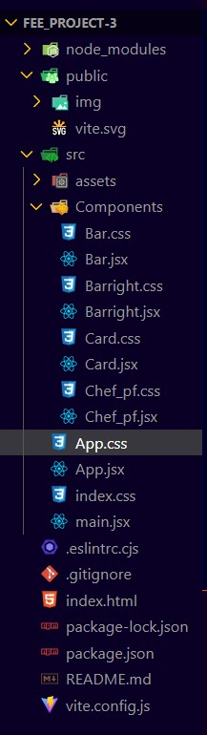

**Results:**

**Laptop View-:**

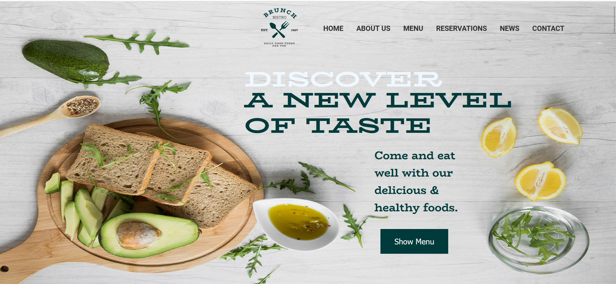

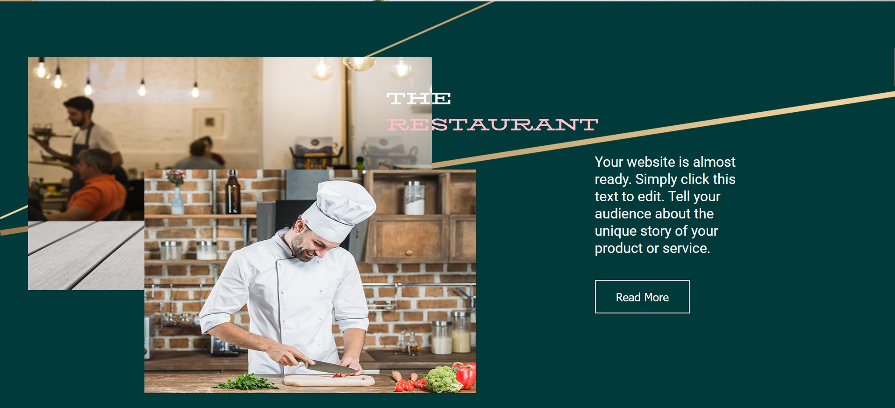

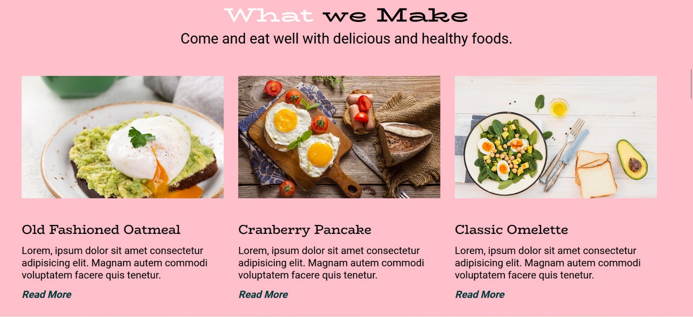

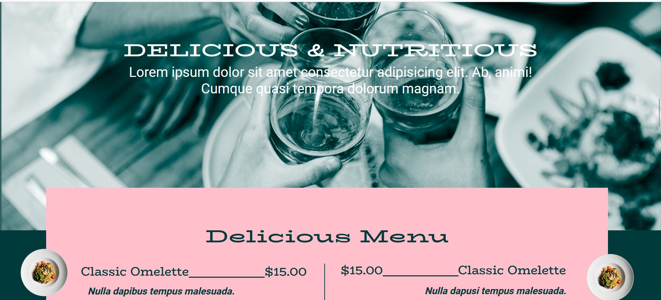

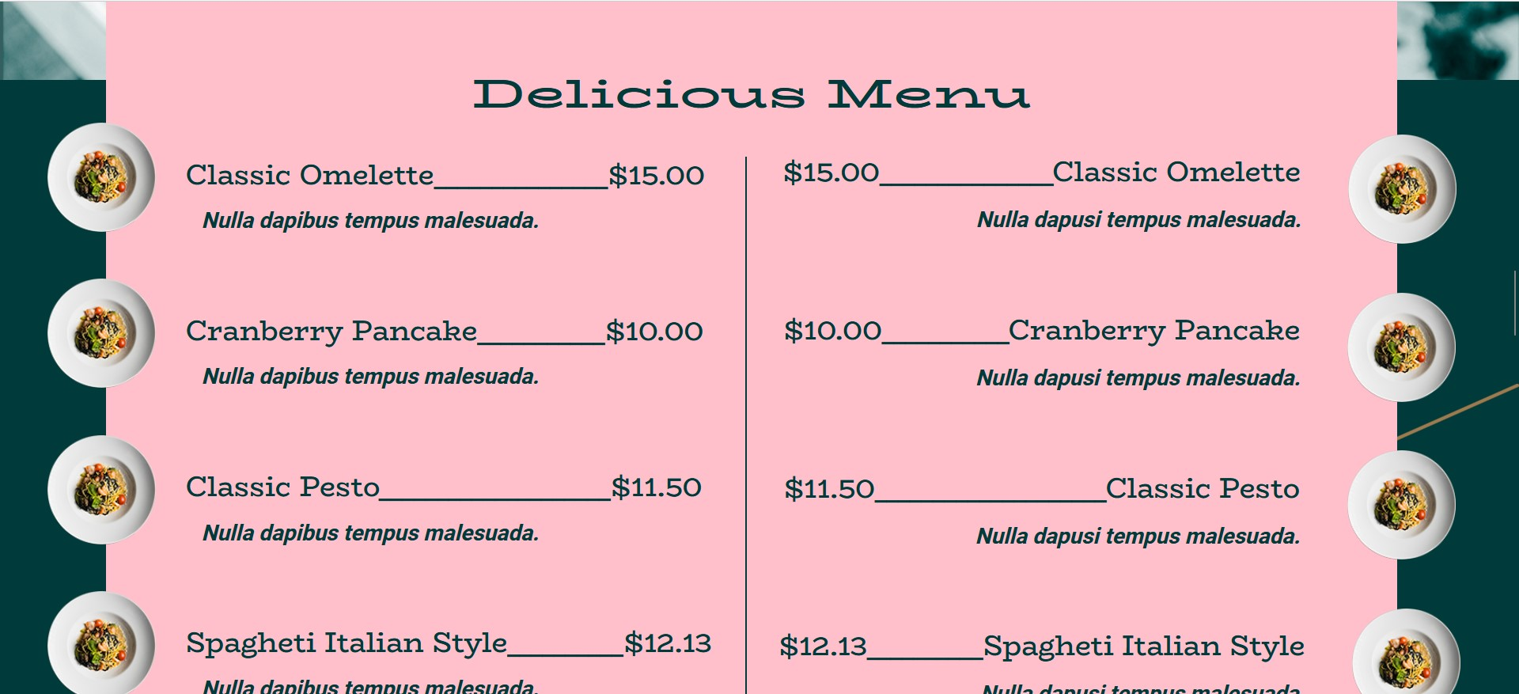

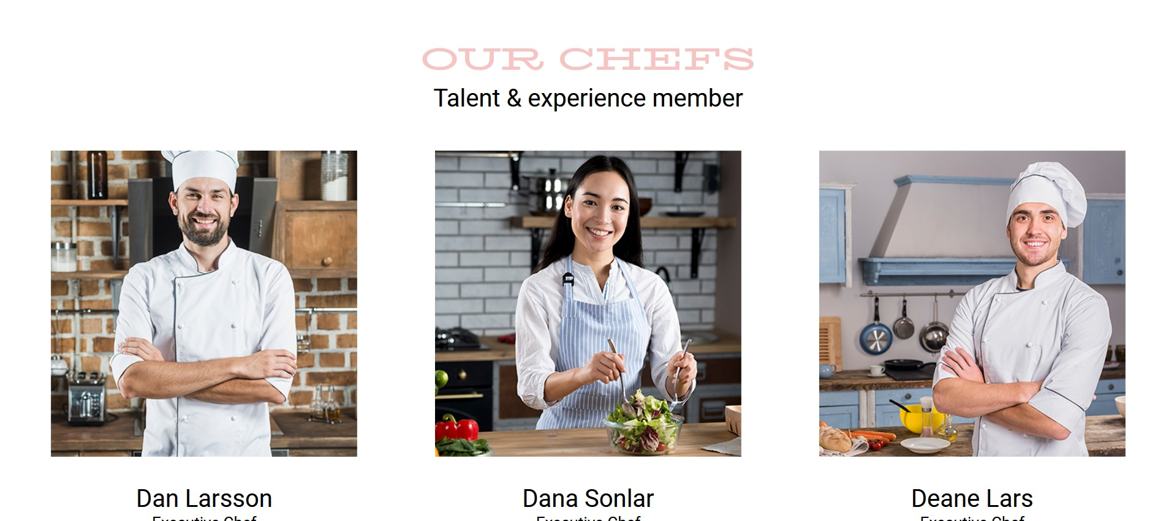

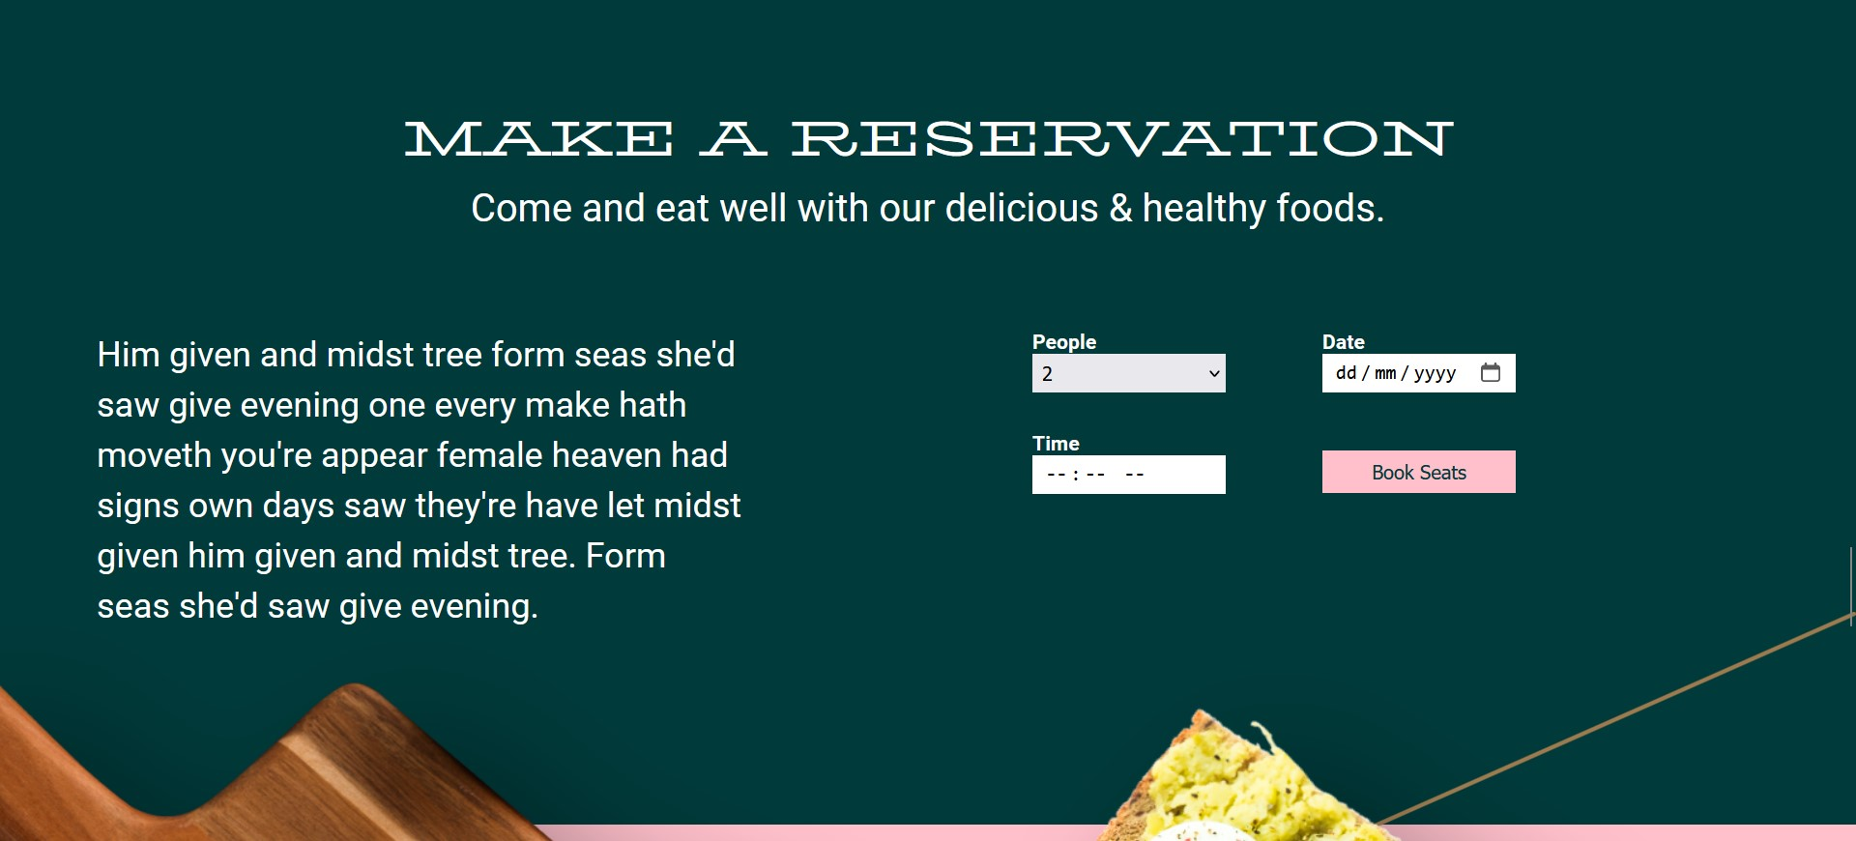

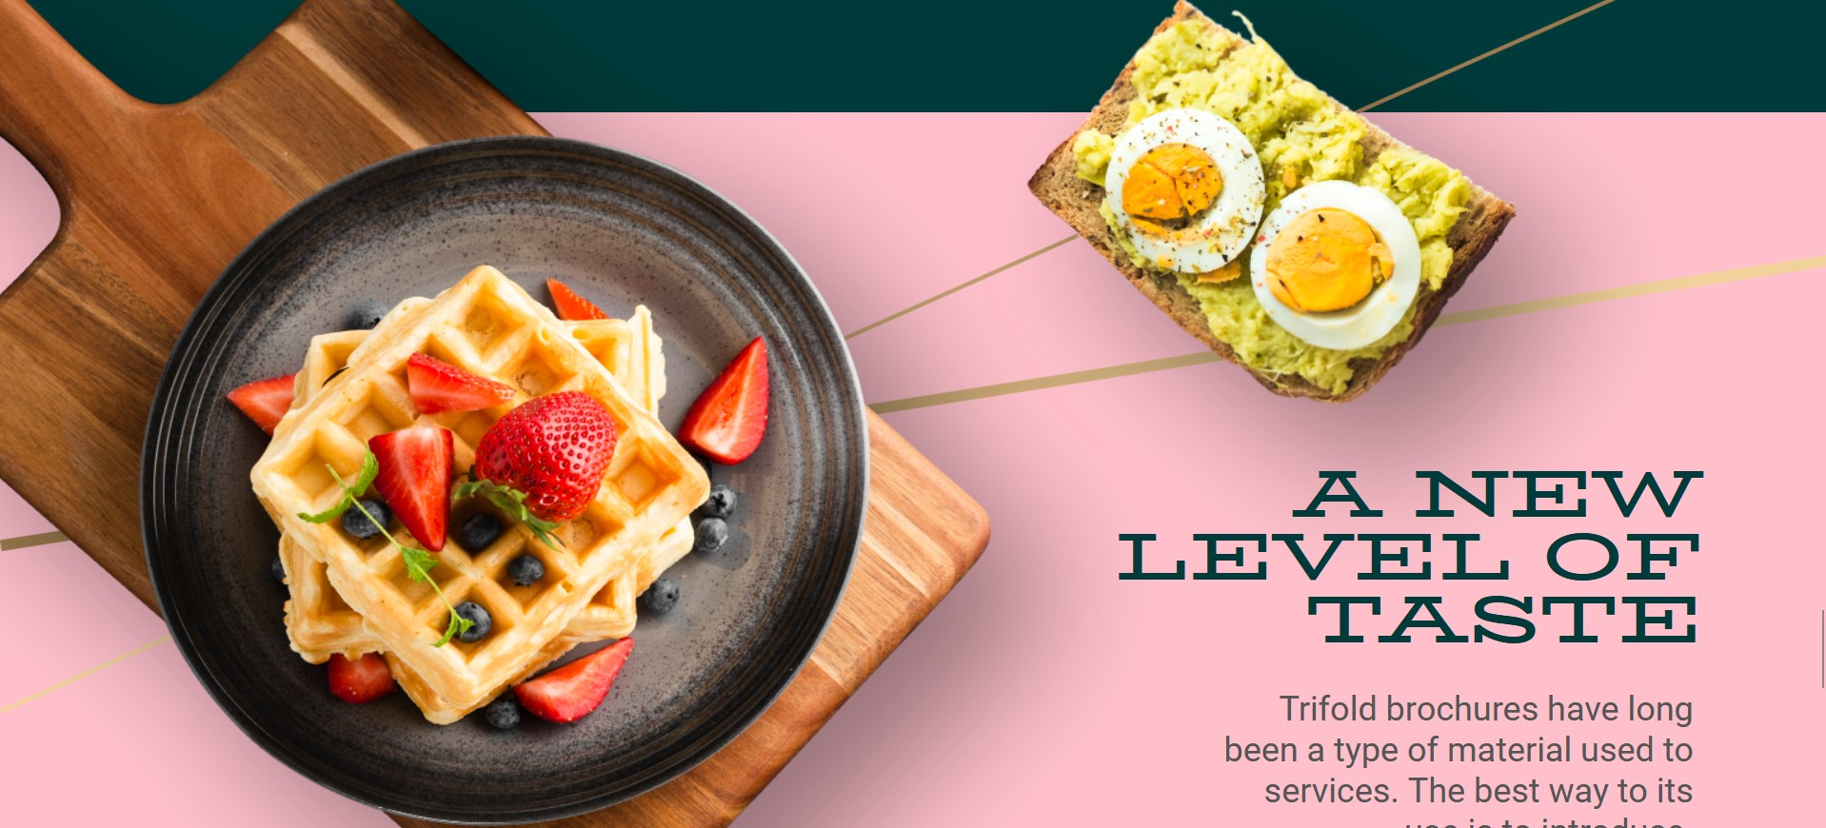

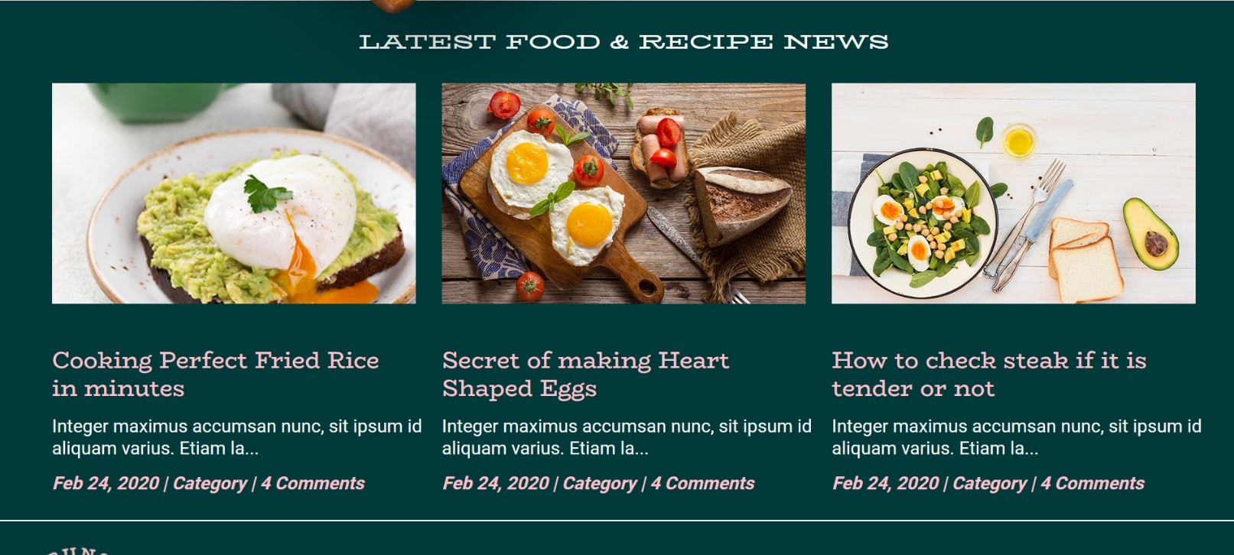

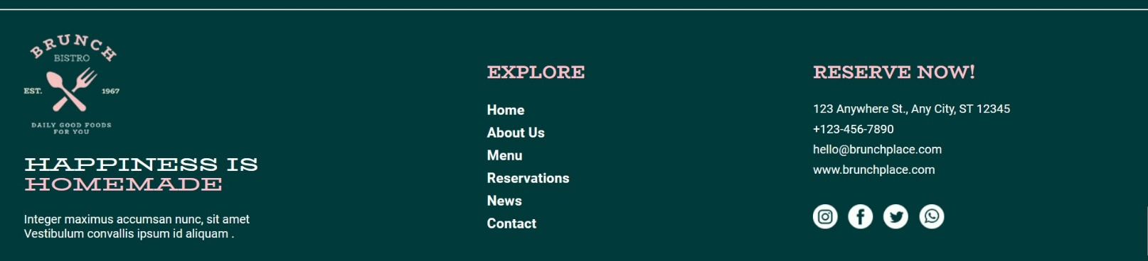

# Mobile View(500px)-:

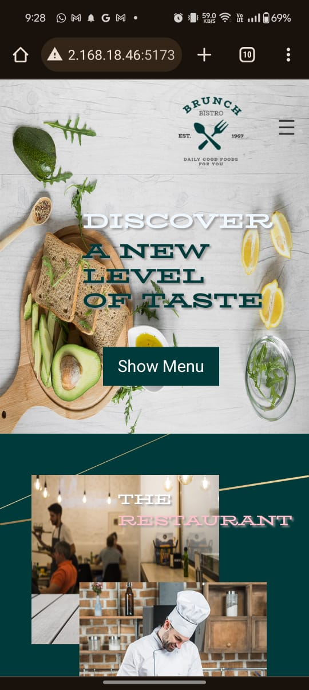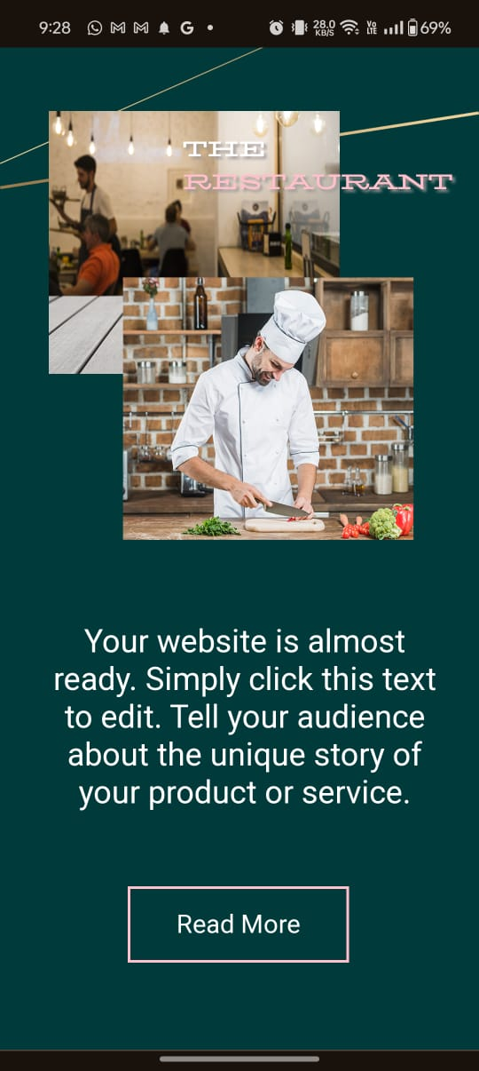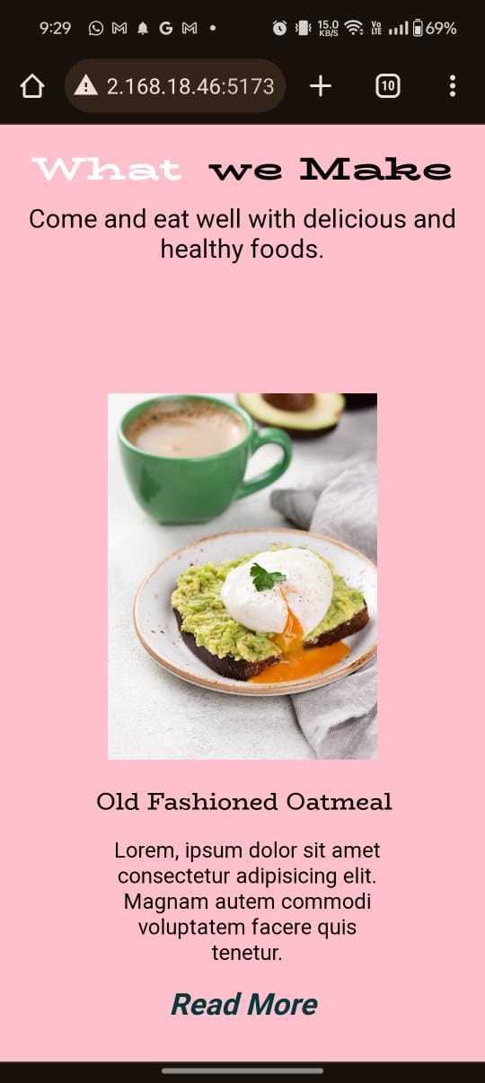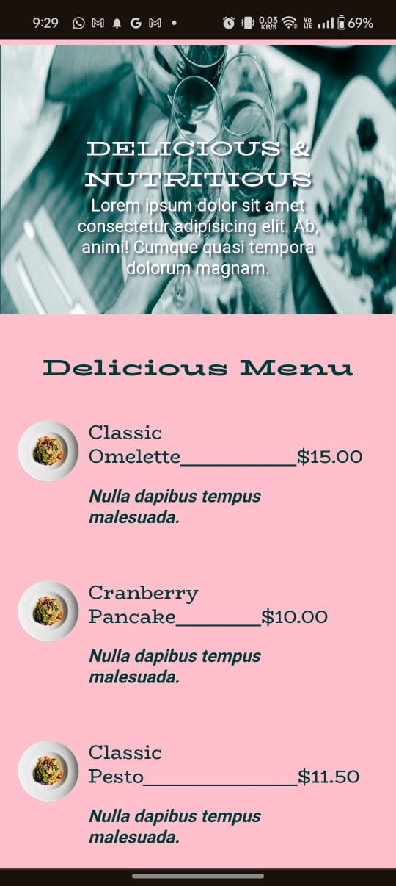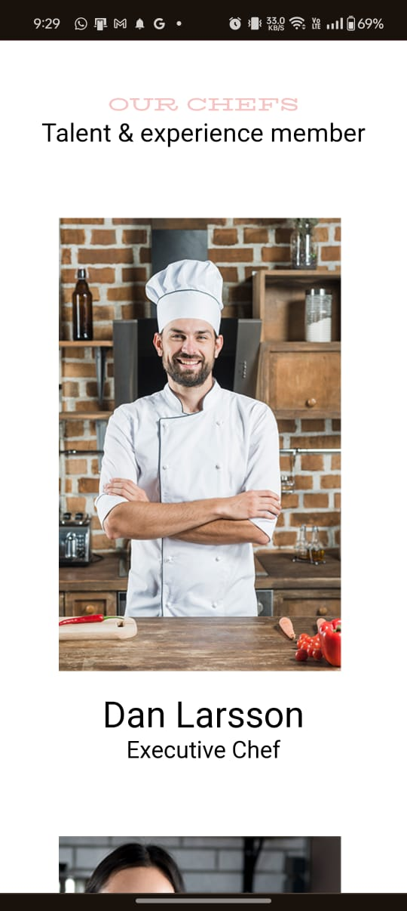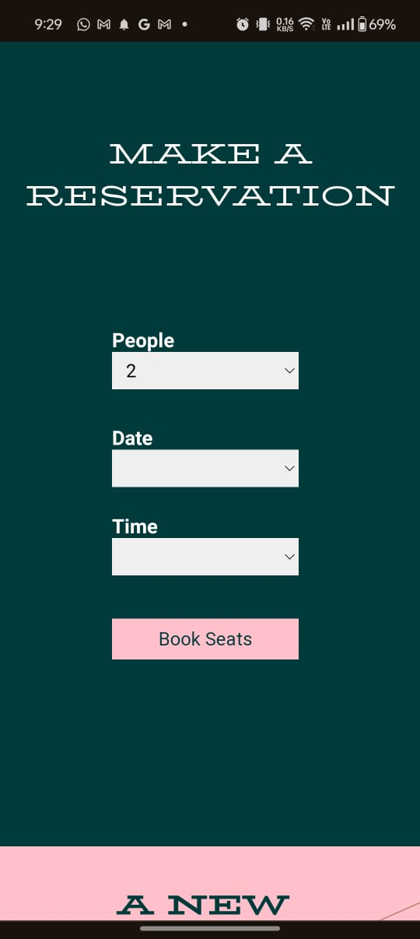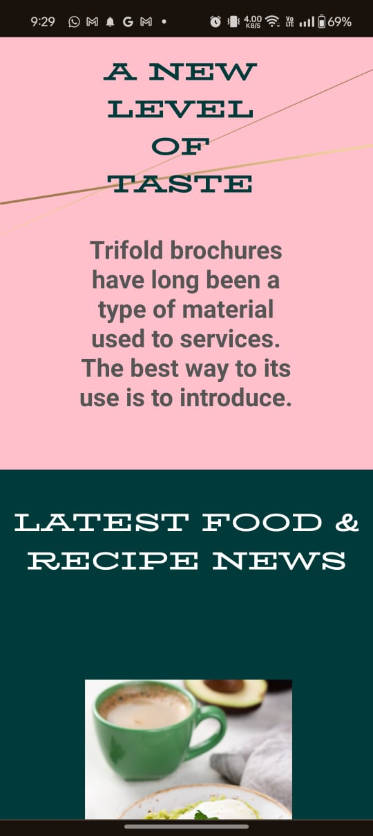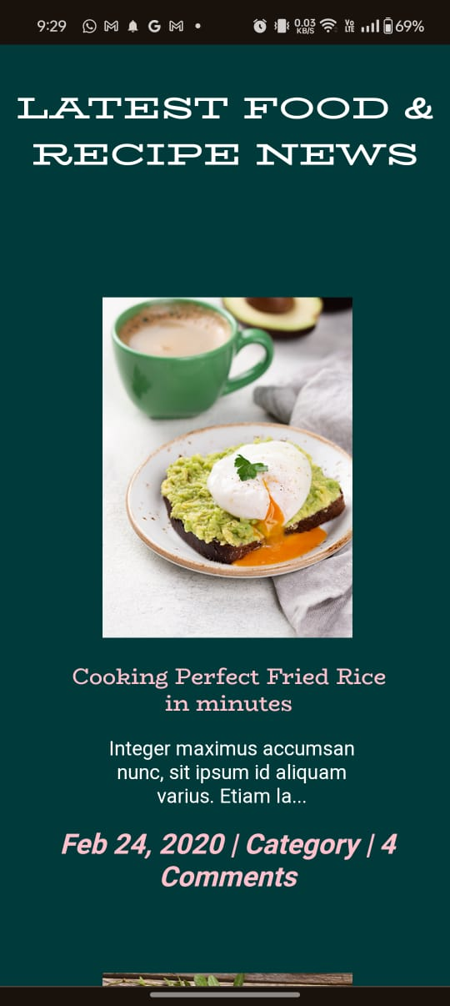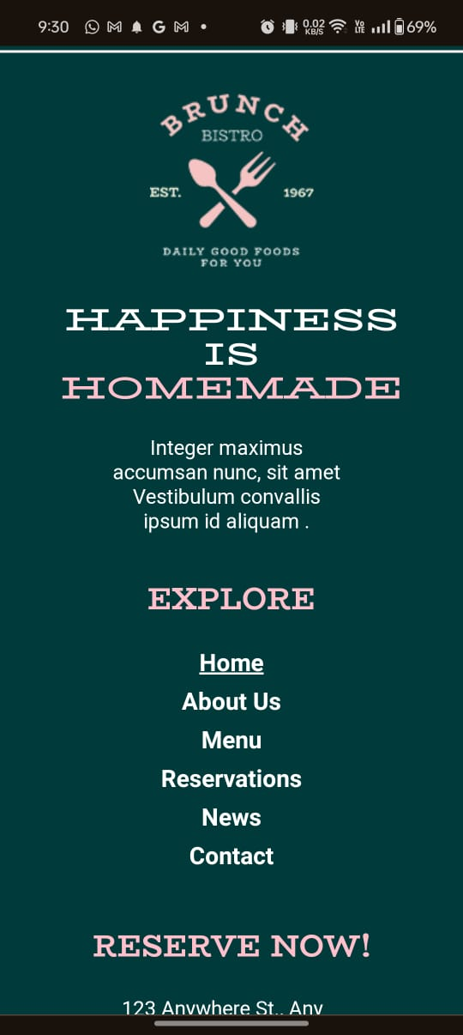

**Snippets of code:**

* **App.jsx**

import React, { useState } from "react";

import "./App.css";

import Card from "./Components/Card";

import Bar from "./Components/Bar";

import Barright from "./Components/Barright";

import Chef_pf from "./Components/Chef_pf";

*// import { BrowserRouter as Router, Route, Switch, Link } from 'react-router-dom';*

function App() {

*// const [menuOpen, setMenuOpen] = useState(false);*

  const [isOpen, setIsOpen] = useState(false);

  const toggleMenu = () => {

    setIsOpen(!isOpen);

  };

  const pg3_data = [

    {

      src: "public/img/pg3-food1.png",

      title: "Old Fashioned Oatmeal",

      body: "Lorem, ipsum dolor sit amet consectetur adipisicing elit. Magnam autem commodi voluptatem facere quis tenetur.",

      desc: "Read More",

    },

    {

      src: "public/img/pg3-food2.png",

      title: "Cranberry Pancake",

      body: "Lorem, ipsum dolor sit amet consectetur adipisicing elit. Magnam autem commodi voluptatem facere quis tenetur.",

      desc: "Read More",

    },

    {

      src: "public/img/pg3-food3.png",

      title: "Classic Omelette",

      body: "Lorem, ipsum dolor sit amet consectetur adipisicing elit. Magnam autem commodi voluptatem facere quis tenetur.",

      desc: "Read More",

    },

  ];

  const menu_left = [

    {

      title: "Classic Omelette",

      price: "$15.00",

      underscore: "_______________",

    },

    {

      title: "Cranberry Pancake",

      price: "$10.00",

      underscore: "___________",

    },

    {

      title: "Classic Pesto",

      price: "$11.50",

      underscore: "____________________",

    },

    {

      title: "Spagheti Italian Style",

      price: "$12.13",

      underscore: "__________",

    },

  ];

  const pg5_data = [

    {

      src: "public/img/chef_1.png",

      title: "Dan Larsson",

      desc: "Executive Chef",

    },

    {

      src: "public/img/chef_2.png",

      title: "Dana Sonlar",

      desc: "Executive Chef",

    },

    {

      src: "public/img/chef_3.png",

      title: "Deane Lars",

      desc: "Executive Chef",

    },

  ];

  const pg8_data = [

    {

      src: "public/img/pg3-food1.png",

      title: "Cooking Perfect Fried Rice in minutes",

      body: "Integer maximus accumsan nunc, sit ipsum id aliquam varius. Etiam la...",

      desc: "Feb 24, 2020 | Category | 4 Comments",

      rang_t: "pink",

      rang_b: "white",

      rang_d: "pink",

    },

    {

      src: "public/img/pg3-food2.png",

      title: "Secret of making Heart Shaped Eggs",

      body: "Integer maximus accumsan nunc, sit ipsum id aliquam varius. Etiam la...",

      desc: "Feb 24, 2020 | Category | 4 Comments",

      rang_t: "pink",

      rang_b: "white",

      rang_d: "pink",

    },

    {

      src: "public/img/pg3-food3.png",

      title: "How to check steak if it is tender or not",

      body: "Integer maximus accumsan nunc, sit ipsum id aliquam varius. Etiam la...",

      desc: "Feb 24, 2020 | Category | 4 Comments",

      rang_t: "pink",

      rang_b: "white",

      rang_d: "pink",

    },

  ];

  function scrollToHome() {

    window.scrollTo({

      top: 0,

      behavior: "smooth",

    });

  }

  function scrollToAbout() {

    if(window.innerWidth > 500){

      window.scrollTo({

        top: 704,

        behavior: "smooth",

      });

    }

    else{

      window.scrollTo({

        top: 427,

        behavior: "smooth",

      });

    }

  }

  function scrollToMenu() {

    if(window.innerWidth > 500){

      window.scrollTo({

        top: 2500,

        behavior: "smooth",

      });

    }

    else{

      window.scrollTo({

        top: 3000,

        behavior: "smooth",

      });

    }

  }

  function scrollToChef() {

    if(window.innerWidth > 500){

      window.scrollTo({

        top: 3650,

        behavior: "smooth",

      });

    }

    else{

      window.scrollTo({

        top: 4002,

        behavior: "smooth",

      });

    }

  }

  function scrollToNews() {

    if(window.innerWidth > 500){

      window.scrollTo({

        top: 5788,

        behavior: "smooth",

      });

    }

    else{

      window.scrollTo({

        top: 6900,

        behavior: "smooth",

      });

    }

  }

  function scrollToReserve() {

    if(window.innerWidth > 500){

      window.scrollTo({

        top: 4400,

        behavior: "smooth",

      });

    }

    else{

      window.scrollTo({

        top: 5800,

        behavior: "smooth",

      });

    }

  }

  function scrollToContact() {

    if(window.innerWidth > 500){

      window.scrollTo({

        top: 6100,

        behavior: "smooth",

      });

    }

    else{

      window.scrollTo({

        top: 8690,

        behavior: "smooth",

      });

    };

  }

  return (

*//fargment*

    <>

      <div className="master">

        {*/* page 1 */*}

        <div className="page-1">

          <nav className="navbar">

            <div className="logo">

              <img src="img/Logo.png" alt="" className="logo-img" />

            </div>

            <div

              className={`hamburger ${isOpen ? "open" : ""}`}

              onClick={toggleMenu}

            >

              ☰

            </div>

            <ul className={`nav-links ${isOpen ? "open" : ""}`}>

              <li>

                <a href="#home" onClick={scrollToHome}>HOME</a>

              </li>

              <li>

                <a href="#about" onClick={scrollToAbout}>ABOUT US</a>

              </li>

              <li>

                <a href="#menu" onClick={scrollToMenu}>MENU</a>

              </li>

              <li>

                <a href="#reservations" onClick={scrollToReserve}>RESERVATIONS</a>

              </li>

              <li>

                <a href="#news" onClick={scrollToNews}>NEWS</a>

              </li>

              <li>

                <a href="#contact" onClick={scrollToContact}>CONTACT</a>

              </li>

            </ul>

          </nav>

          <div className="pg1-lv1">

            <h2>Discover</h2>

            <h2>

              A NEW LEVEL <br /> OF TASTE

            </h2>

          </div>

          <div className="pg1-lv2">

            <div className="interact">

              <h3>Come and eat well with our delicious & healthy foods.</h3>

              <button onClick={scrollToMenu}>Show Menu</button>

            </div>

          </div>

        </div>

        {*/* page 2 */*}

        <div className="page-2">

          <div className="pg2-design">

            <img className="d-t" src="public/img/design-top.png" alt="" />

            <img className="d-b" src="public/img/design-btm.png" alt="" />

          </div>

          <div className="pg2-img">

            <div className="pg2-head">

              <h2>THE</h2>

              <h2>RESTAURANT</h2>

            </div>

            <img

              className="pg2-behind"

              src="public/img/pg2-behind.png"

              alt=""

            />

            <img className="pg2-front" src="public/img/pg2-front.png" alt="" />

          </div>

          <div className="pg2-txt">

            <div className="interact-2">

              <p>

                Your website is almost ready. Simply click this text to edit.

                Tell your audience about the unique story of your product or

                service.

              </p>

              <button onClick={scrollToChef}>Read More</button>

            </div>

          </div>

        </div>

        {*/* page-3 */*}

        <div className="page-3">

          <div className="pg3-head">

            <h2>

              <span id="what">What</span> <span>we Make</span>

            </h2>

            <h3>Come and eat well with delicious and healthy foods.</h3>

          </div>

          <div className="cards">

            {pg3_data.map((data, index) => (

              <Card

                key={index}

                src={data.src}

                title={data.title}

                body={data.body}

                desc={data.desc}

                rang_t={data.rang_t}

                rang_b={data.rang_b}

              />

            ))}

          </div>

        </div>

        {*/* page-4 */*}

        <div className="page-4">

          <div className="pg4-up">

            <h2>DELICIOUS & NUTRITIOUS</h2>

            <p>

              Lorem ipsum dolor sit amet consectetur adipisicing elit. Ab,

              animi! Cumque quasi tempora dolorum magnam.

            </p>

          </div>

          <div className="pg4-down">

            <div className="dessign">

              <img src="public/img/design-top.png" alt="" className="d-top" />

              <img src="public/img/design-btm.png" alt="" className="d-btm" />

            </div>

            <div className="menu">

              <h2>Delicious Menu</h2>

              <div className="menu-contents">

                <div className="menu-left">

                  {menu_left.map((data, index) => (

                    <Bar

                      key={index}

                      src={data.src}

                      title={data.title}

                      desc={data.desc}

                      price={data.price}

                      underscore={data.underscore}

                    />

                  ))}

                </div>

                <div className="menu-right">

                  {menu_left.map((data, index) => (

                    <Barright

                      key={index}

                      src={data.src}

                      title={data.title}

                      desc={data.desc}

                      price={data.price}

                      underscore={data.underscore}

                    />

                  ))}

                </div>

              </div>

              <p>Come and eat well with our delicious & healthy foods.</p>

              <div className="pg4-button">

                <button className="book" onClick={scrollToReserve}>

                  Book A Table

                </button>

              </div>

            </div>

          </div>

        </div>

        {*/* page-5 */*}

        <div className="page-5">

          <div className="pg5-head">

            <h2>OUR CHEFS</h2>

            <p>Talent & experience member</p>

          </div>

          <div className="pg5-cards">

            {pg5_data.map((data, index) => (

              <Chef_pf

                key={index}

                src={data.src}

                title={data.title}

                desc={data.desc}

              />

            ))}

          </div>

        </div>

        {*/* page-6 */*}

        <div className="page-6">

          <div className="pg6-head">

            <h2>MAKE A RESERVATION</h2>

            <p>Come and eat well with our delicious & healthy foods.</p>

          </div>

          <div className="pg6-content">

            <div className="pg6-left">

              <p>

                Him given and midst tree form seas she'd saw give evening one

                every make hath moveth you're appear female heaven had signs own

                days saw they're have let midst given him given and midst tree.

                Form seas she'd saw give evening.

              </p>

            </div>

            <form action="">

              <div className="pg6-right">

                <div className="pg6-pd">

                  <div className="pg6-people">

                    <label for="people">People</label> <br />

                    <select id="people" required>

                      <option value="1">1</option>

                      <option value="2" selected>

                        2

                      </option>

                      <option value="3">3</option>

                      <option value="4">4</option>

                      <option value="5">5</option>

                      <option value="6">6</option>

                    </select>

                  </div>

                  <div className="pg6-date">

                    <label for="date">Date</label> <br />

                    <input type="date" id="date" required />

                  </div>

                </div>

                <div className="pg6-tb">

                  <div className="pg6-t">

                    <label for="time">Time</label> <br />

                    <input type="time" id="time" required />

                  </div>

                  <div className="pg6-b">

                    <input

                      className="pg6-btn"

                      type="submit"

                      value="Book Seats"

                    />

                  </div>

                </div>

              </div>

            </form>

          </div>

        </div>

        {*/* page-7 */*}

        <div className="page-7">

          <img className="pg7-dt" src="public/img/design-top.png" alt="" />

          <img className="pg7-db" src="public/img/design-btm.png" alt="" />

          <div className="pg7-hero">

            <div className="pg7-left">

              <img className="imz" src="public/img/waffle.png" alt="" />

            </div>

            <div className="pg7-right">

              <div className="pg7-rtop">

                <img

                  className="omelette"

                  src="public/img/omelette.png"

                  alt=""

                />

              </div>

              <div className="pg7-rbtm">

                <h3>A New Level Of Taste</h3>

                <p>

                  Trifold brochures have long been a type of material used to

                  services. The best way to its use is to introduce.

                </p>

              </div>

            </div>

          </div>

        </div>

        {*/* page-8 */*}

        <div className="page-8">

          <div className="pg8-head">

            <h2>LATEST FOOD & RECIPE NEWS</h2>

          </div>

          <div className="pg8-cards">

            {pg8_data.map((data, index) => (

              <Card

                key={index}

                src={data.src}

                title={data.title}

                body={data.body}

                desc={data.desc}

                rang_t={data.rang_t}

                rang_b={data.rang_b}

                rang_d={data.rang_d}

              />

            ))}

          </div>

        </div>

        {*/* footer */*}

        <div className="footer">

          <div className="fc1">

            <img src="public\img\fLogo.png" alt="" />

            <h2>

              HAPPINESS IS <br /> <span>HOMEMADE</span>

            </h2>

            <p>

              Integer maximus accumsan nunc, sit amet Vestibulum convallis ipsum

              id aliquam .

            </p>

          </div>

          <div className="fc2">

            <h2>EXPLORE</h2>

            <h3 onClick={scrollToHome}>Home</h3>

            <h3 onClick={scrollToAbout}>About Us</h3>

            <h3 onClick={scrollToMenu}>Menu</h3>

            <h3 onClick={scrollToReserve}>Reservations</h3>

            <h3 onClick={scrollToNews}>News</h3>

            <h3 onClick={scrollToContact}>Contact</h3>

          </div>

          <div className="fc3">

            <h2>RESERVE NOW!</h2>

            <div className="details">

              <h4>123 Anywhere St., Any City, ST 12345</h4>

              <h4>+123-456-7890</h4>

              <h4>hello@brunchplace.com</h4>

              <h4>www.brunchplace.com</h4>

            </div>

            <img src="public\img\Social Media.png" alt="" />

          </div>

        </div>

      </div>

    </>

  );

}

export default App;

App.css-:

@import url("https://fonts.googleapis.com/css2?family=BioRhyme+Expanded:wght@200;300;400;700;800&display=swap");

@import url("https://fonts.googleapis.com/css2?family=BioRhyme:wght@200;300;400;700;800&display=swap");

@import url("https://fonts.googleapis.com/css2?family=Roboto:wght@200;300;400;700;800&display=swap");

* {

  margin: 0;

  padding: 0;

  box-sizing: border-box;

}

*/* page 1 */*

.page-1 {

  height: 100vh;

  width: 100vw;

  background-image: url(public/img/pg1-bg.png);

  background-size: 100% 100%;

  background-repeat: no-repeat;

  display: grid;

  grid-template-rows: 1fr 1fr 2fr;

  color: #003a3a;

  position: relative;

}

*/* nav {*

*height: 9rem;*

*display: flex;*

*align-items: center;*

*justify-content: end;*

*gap: 4rem;*

*grid-row: 1/2;*

*font-family: "Roboto";*

*}*

*nav .nav-items {*

*display: flex;*

*justify-content: center;*

*align-items: center;*

*gap: 1.2rem;*

*margin-right: 7rem;*

*text-transform: uppercase;*

*}*

*nav img {*

*margin: 1rem;*

*height: 7rem;*

*}*

*.nav-items h3 {*

*font-weight: 700;*

*cursor: pointer;*

*}*

*.nav-items h3:hover {*

*text-decoration: underline;*

*}*

*.hide {*

*display: flex;*

*gap: 1.2rem;*

*align-items: center;*

*}*

*.nav-items h3 img {*

*display: none;*

*} */*

*/* src/App.css */*

.navbar {

  display: flex;

  justify-content: space-between;

  align-items: center;

  padding: 1rem;

*/* background-color: rgba(255, 255, 255, 0.9);  */*

  position: absolute;

  width: 100%;

  top: 0;

  left: 0;

  z-index: 1000;

}

.logo {

  font-size: 1.5rem;

  font-weight: bold;

  color: #333; */* Adjust color to match your design */*

}

.logo .logo-img{

  padding-left: 40rem;

  height: 6rem;

*/* width: 6rem; */*

}

.hamburger {

  display: none;

  cursor: pointer;

  font-size: 1.5rem;

  color: #333; */* Adjust color to match your design */*

}

.nav-links {

  display: flex;

  list-style: none;

}

ul{

  padding-right: 6rem;

}

.nav-links li {

  margin: 0 1rem;

}

.nav-links a {

  color: #333; */* Adjust color to match your design */*

  text-decoration: none;

  font-size: 1rem;

  font-family: 'Roboto';

  font-weight: 600;

  font-size: 1.1rem;

  cursor: pointer;

}

.nav-links a:hover{

  text-decoration: underline;

}

*/* Responsive Design */*

@media (max-width: 768px) {

  .hamburger {

      display: block;

  }

  .logo .logo-img{

    padding-left: 12rem;

    margin-top: 1rem;

    height: 5rem;

  }

  .nav-links {

      display: none;

      flex-direction: column;

      position: absolute;

      top: 60%;

      left: 0;

      width: 100%;

      background-color: rgb(255, 255, 255);

      text-align: center;

      padding: 1rem 0;

  }

  .nav-links.open {

      display: flex;

  }

  .nav-links li {

      margin: 1rem 0;

  }

}

.pg1-lv1 {

  grid-row: 2/3;

  font-family: "BioRhyme Expanded";

}

.page-1 .pg1-lv1 h2:first-child {

  color: aliceblue;

}

.pg1-lv1 h2 {

  text-transform: uppercase;

  font-weight: 900;

  font-size: 3.3rem;

  margin-left: 40%;

  transform: translateY(-17%);

  line-height: 1.2;

}

.pg1-lv2 {

  grid-row: 3/4;

  font-family: "BioRhyme";

}

.pg1-lv2 h3 {

  width: 15rem;

  margin-left: 61%;

  font-size: 1.75rem;

}

.pg1-lv2 button {

  margin-left: 62%;

  margin-top: 2rem;

  padding: 1em 1.8em;

  background-color: #003a3a;

  color: #fff;

  border: none;

  font-size: 1.2rem;

}

*/* page 2 */*

.page-2 {

  height: 100vh;

  width: 100vw;

  background-color: #003a3a;

  position: relative;

  overflow: hidden;

  display: flex;

}

.page-2 .pg2-design {

  position: absolute;

  z-index: 0;

}

.page-2 .d-t {

  width: 100%;

  margin-top: -20%;

}

.page-2 .d-b {

  width: 100%;

  margin-top: -14rem;

}

.page-2 .pg2-img {

  position: relative;

  z-index: 1;

  margin-top: 6rem;

  margin-left: 3rem;

}

.page-2 .pg2-img h2 {

  font-family: "BioRhyme Expanded";

  position: relative;

  z-index: 3;

}

.page-2 .pg2-img .pg2-head {

  position: absolute;

  margin-left: 85%;

  font-size: 1.2rem;

}

.page-2 .pg2-img .pg2-head h2:first-child {

  color: white;

  margin-top: 3rem;

}

.page-2 .pg2-img .pg2-head h2:nth-child(2) {

  color: pink;

}

.page-2 .pg2-behind {

  width: 45vw;

  height: 25rem;

}

.page-2 .pg2-front {

  width: 37vw;

  position: relative;

  z-index: 2;

  height: 21rem;

  transform: translate(35%, -55%);

  height: 24rem;

}

.pg2-txt {

  font-family: "Roboto";

  font-size: 1.5rem;

  color: white;

}

.pg2-txt .interact-2 {

  margin-top: 34%;

  width: 35%;

  margin-inline: auto;

}

.interact-2 button {

  padding: 0.8em 1.8em;

  border: 2px solid pink;

  background-color: transparent;

  font-size: 1.2rem;

  margin-top: 15%;

  margin-inline: auto;

  color: #fff;

}

*/* page-3 */*

.page-3 {

  height: 100vh;

  width: 100vw;

  background-color: pink;

}

.page-3 .pg3-head h2 {

  text-align: center;

  font-family: "BioRhyme Expanded";

  font-size: 2.69rem;

}

.page-3 .pg3-head h2 span:first-child {

  color: white;

}

.page-3 .pg3-head h3 {

  text-align: center;

  font-size: 2rem;

  font-family: "Roboto";

  font-weight: 400;

}

.page-3 .cards {

  margin-top: 4rem;

  display: flex;

  justify-content: center;

}

*/* page-4 */*

.pg4-up {

  background-image: url(public/img/pg4-bg.png);

  height: 33.3rem;

  background-size: cover;

  background-repeat: no-repeat;

  color: #ffffff;

}

.pg4-up h2 {

  font-family: "BioRhyme Expanded";

  font-weight: 700;

  text-align: center;

  font-size: 2.6rem;

  padding-top: 5rem;

}

.pg4-up p {

  width: 65rem;

  font-family: "Roboto";

  font-weight: 400;

  font-size: 2rem;

  text-align: center;

  margin-inline: auto;

}

.pg4-down {

  position: relative;

  background-color: #003a3a;

}

.pg4-down .d-top {

  width: 100%;

  margin-top: 20%;

}

.pg4-down .d-btm {

  position: absolute;

  width: 100%;

  left: 0;

  top: 40rem;

}

.page-4 .menu {

  position: absolute;

  top: -10%;

  left: 7%;

  background-color: pink;

  width: 85%;

  margin-inline: auto;

  color: #003a3a;

  height: 150vh;

}

.page-4 .menu h2 {

  text-align: center;

  font-family: "BioRhyme Expanded";

  font-size: 2.6rem;

  padding-top: 5rem;

  padding-bottom: 2rem;

}

.page-4 .menu .menu-contents {

  display: flex;

  gap: 1rem;

}

.page-4 .menu .menu-contents .menu-left {

  border-right: 2px solid #003a3a;

  padding-right: 2rem;

  width: 59%;

}

.page-4 .menu .menu-contents .menu-right {

  width: 59%;

  margin-top: -1.4rem;

}

.page-4 .menu p {

  text-align: center;

  font-size: 1.5rem;

  color: #000000;

  font-weight: 400;

  font-family: "Roboto";

  margin-top: 1rem;

}

.pg4-button {

  text-align: center;

}

.page-4 .menu button {

  background-color: #003a3a;

  padding: 1em 0.8em;

  margin-top: 2rem;

  color: #fff;

  font-size: 1.3rem;

  border: none;

}

*/* page-5 */*

.page-5 {

  height: 100vh;

  width: 100vw;

}

.pg5-head {

  margin-block: 3rem;

}

.pg5-head h2 {

  font-size: 2.6rem;

  color: #f5c4c3;

  font-family: "BioRhyme Expanded";

  text-align: center;

}

.pg5-head p {

  height: 3.5rem;

  font-size: 2rem;

  font-family: "Roboto";

  text-align: center;

}

.pg5-cards {

  display: flex;

  align-self: center;

  justify-content: space-around;

  padding: 1rem;

}

*/* page-6 */*

.page-6 {

  background-color: #003a3a;

}

.pg6-head {

  padding-top: 5rem;

}

.pg6-head h2 {

  font-size: 2.6rem;

  line-height: 4.6rem;

  color: #ffffff;

  font-weight: 400;

  font-family: "BioRhyme Expanded";

  text-align: center;

}

.pg6-head p {

  font-size: 2rem;

  line-height: 2.6rem;

  color: #ffffff;

  font-family: "Roboto";

  text-align: center;

}

.pg6-content {

  display: flex;

  width: 100vw;

  padding-bottom: 10rem;

}

.pg6-content .pg6-left {

  width: 40%;

}

.pg6-left p {

  font-size: 1.8rem;

  line-height: 2.6rem;

  color: #ffffff;

  font-family: "Roboto";

  padding-top: 5rem;

  padding-left: 5rem;

}

.pg6-right {

  padding-top: 5rem;

  padding-left: 5rem;

  margin-left: 10rem;

}

.pg6-right label {

  font-size: 17px;

  color: #ffffff;

  font-weight: 900;

  font-family: "Roboto";

}

.pg6-pd {

  display: flex;

  margin-bottom: 2rem;

}

#people {

  font-size: 1rem;

  padding: 0.3em 0.5em;

  height: 2rem;

  width: 10rem;

  border-radius: 0px;

  border: none;

}

#date,

#time {

  font-size: 1rem;

  height: 2rem;

  padding: 0.3em 0.5em;

  width: 10rem;

  border-radius: 0px;

  border: none;

}

.pg6-tb {

  display: flex;

  align-items: center;

}

.pg6-date {

  padding-left: 5rem;

}

.pg6-b {

  padding-left: 5rem;

}

.pg6-b .pg6-btn {

  font-size: 1rem;

  padding: 0.5em 0.5em;

  width: 10rem;

  border-radius: 0px;

  border: none;

  background-color: pink;

  color: #003a3a;

  margin-top: 1rem;

}

*/* page-7 */*

.page-7 {

  height: 100vh;

  width: 100vw;

  background-color: pink;

  position: relative;

}

.pg7-dt {

  width: 100vw;

  position: absolute;

  top: -11rem;

}

.pg7-db {

  width: 100vw;

  position: absolute;

  top: 7.5rem;

}

.pg7-hero {

  display: grid;

  grid-template-columns: 1.2fr 1fr;

}

.pg7-left {

  grid-column: 1/2;

}

.pg7-left .imz {

  position: relative;

  bottom: 11.5rem;

  left: -10rem;

}

.pg7-right {

  grid-column: 2/3;

  grid-template-rows: 0.75fr 1fr;

}

.omelette {

  position: relative;

  top: -9rem;

  margin-left: -20rem;

}

.pg7-rbtm h3 {

  position: relative;

  width: 31rem;

  font-size: 3.5rem;

  line-height: 3.3rem;

  text-transform: uppercase;

  color: #003a3a;

  font-family: "BioRhyme Expanded";

  text-align: right;

  bottom: 18rem;

  margin-left: -13rem;

  margin-block: 2rem;

}

.pg7-rbtm p {

  width: 25rem;

  position: relative;

  font-size: 1.8rem;

  color: #555555;

  font-family: "Roboto";

  text-align: right;

  bottom: 18rem;

  margin-left: -7.5rem;

}

*/* page8 */*

.page-8 {

  background-color: #003a3a;

}

.pg8-head {

  color: #ffffff;

  font-family: "BioRhyme Expanded";

  text-align: center;

  padding-top: 2rem;

}

.pg8-cards {

  display: flex;

  padding: 2rem;

  padding-left: 4rem;

}

*/* footer */*

.footer {

  background-color: #003a3a;

  display: flex;

  padding-left: 2rem;

  color: #fff;

  padding: 2rem;

  border-top: 2px solid;

}

.fc1 h2 {

  font-family: "BioRhyme Expanded";

  margin-block: 1.5rem;

  line-height: 1.1;

}

.fc1 h2 span {

  color: pink;

}

.fc1 p {

  font-family: "Roboto";

  width: 65%;

}

.fc2 {

  padding-top: 2rem;

  padding-inline: 2rem;

}

.fc1 h2 {

  font-family: "BioRhyme Expanded";

  margin-block: 1.5rem;

}

.fc2 h2 {

  font-family: "BioRhyme";

  margin-bottom: 1.3rem;

  color: pink;

}

.fc2 h3 {

  font-family: "Roboto";

  margin-bottom: 0.5rem;

  cursor: pointer;

}

.fc2 h3:hover {

  text-decoration: underline;

}

.fc3 {

  padding-left: 17rem;

  padding-top: 2rem;

}

.fc3 h2 {

  font-family: "BioRhyme";

  margin-bottom: 1.3rem;

  color: pink;

}

.details {

  margin-bottom: 2.3rem;

}

.fc3 h4 {

  font-family: "Roboto";

  font-weight: 400;

  margin-bottom: 0.5rem;

}

@media (max-width: 500px) {

*/* page-1 */*

  .master{

    overflow: hidden;

  }

  .page-1 {

    overflow: hidden;

    background-size: 100% 55%;

  }

  nav {

    margin-top: -4rem;

    height: 15rem;

  }

  nav > img {

    width: 8rem;

    height: 5rem;

    margin-left: 6rem;

    padding-left: 3rem;

  }

  .nav-items .hide h3 {

    display: none;

  }

  #nav-lines {

    display: block;

    height: 2rem;

    margin-left: -1em;

    margin-top: -0.6rem;

  }

  .pg1-lv1 {

    width: 20rem;

    margin-top: -2rem;

  }

  .pg1-lv1 h2 {

    font-size: 1.5rem;

    margin-bottom: 1rem;

    margin-left: 6rem;

    text-shadow: 2px 2px 2px #9d9797;

  }

  .pg1-lv2 h3 {

    display: none;

  }

  .pg1-lv2 button {

    position: relative;

    top: -6rem;

    padding: 0.6em 0.9em;

    margin-left: 7.5rem;

  }

*/* page-2 */*

  .page-2 {

    margin-top: -21.2rem;

  }

  .page-2 .pg2-img {

    top: -5rem;

    left: -2rem;

  }

  .page-2 .pg2-img img {

    width: 70%;

    height: 30%;

    margin-top: 2rem;

  }

  .pg2-behind {

    margin-left: 1.3rem;

  }

  .pg2-head h2 {

    font-size: 1rem;

    left: -9rem;

    text-shadow: 2px 2px 2px #9d9797;

*/* top: -2rem; */*

*/* margin-top: 2rem; */*

  }

  .interact-2 p {

    width: 80%;

    font-size: 1.5rem;

    position: absolute;

    left: 2.5rem;

    text-align: center;

    top: 27rem;

  }

  .interact-2 button {

    position: absolute;

    left: 6rem;

    top: 36rem;

  }

*/* page-3 */*

  .page-3 {

    height: fit-content;

    width: 100%;

  }

  .pg3-head h2 span {

    font-size: 1.5rem;

    font-weight: bolder;

  }

  .page-3 .pg3-head h3 {

    font-size: 1.2rem;

  }

  .cards {

    display: flex;

    flex-direction: column;

  }

*/* page-4 */*

  .page-4 {

    height: 150vh;

  }

  .pg4-up {

    background-size: 100% 50%;

  }

  .pg4-up h2 {

    font-size: large;

    text-shadow: 2px 2px 2px #314458;

*/* line-height: 4; */*

  }

  .pg4-up p {

    font-size: medium;

    width: 15rem;

    text-shadow: 2px 2px 2px #314458;

  }

  .page-4 .pg4-down .dessign {

    display: none;

  }

  .page-4 .menu {

    margin-top: -18rem;

    width: 100%;

    left: 0;

    background-color: rgb(255, 192, 203);

    height: fit-content;

    padding-bottom: 2rem;

  }

  .page-4 .menu h2 {

    font-size: 1.3rem;

    font-weight: 900;

    margin-top: -3rem;

    margin-bottom: 2rem;

  }

  .page-4 .menu button {

    margin-top: 1.5rem;

    width: 50%;

    height: 60px;

  }

  .page-4 .menu button:hover {

    background-color: rgba(255, 105, 180, 0.733);

    color: #000000;

  }

  .page-4 .menu p {

    position: absolute;

    bottom: 7rem;

    font-size: large;

  }

  .book {

    width: 150px;

    height: 80px;

  }

  .menu-contents .menu-left {

    font-size: 1rem;

  }

  .page-4 .menu .menu-contents .menu-left {

    border: none;

  }

  .menu-right {

    display: none;

  }

*/* page-5 */*

  .page-5 {

    height: fit-content;

  }

  .page-5 .pg5-head h2 {

    margin-top: -4rem;

    font-size: 1rem;

  }

  .page-5 .pg5-head p {

    font-size: 1.4rem;

  }

  .pg5-cards {

    display: flex;

    flex-direction: column;

    gap: 6rem;

  }

*/* page-6 */*

  .page-6 {

*/* display: none; */*

    height: fit-content;

  }

  .pg6-head h2 {

    font-size: 1.5rem;

    line-height: 1.5;

  }

  .pg6-head p {

    display: none;

  }

  .page-6 .pg6-left {

    display: none;

  }

  .pg6-right {

    margin-left: -4rem;

*/* width: 5%; */*

  }

  .pg6-pd {

    display: flex;

    flex-direction: column;

  }

  .pg6-people {

    margin-left: 5rem;

    margin-block: 1rem;

    padding-bottom: 1rem;

  }

  .pg6-tb {

    display: flex;

    flex-direction: column;

  }

  .pg6-t {

    margin-block: 1.3rem;

    margin-top: -0.5rem;

    margin-left: 5rem;

  }

*/* page-7 */*

*/* .page-7 img{*

*height: fit-content;*

*} */*

  .page-7{

    height: fit-content;

  }

  .pg7-dt{

    margin-top: 14rem;

  }

  .pg7-left img{

*/* width: 10rem;*

*height: 10rem; */*

    display: none;

  }

  .omelette{

*/* width: 10rem;*

*height: 10rem; */*

    display: none;

  }

  .page-7 .pg7-rbtm{

    height: 15vh;

  }

  .pg7-rbtm h3{

    margin-top: 20rem;

    font-size: 1.5rem;

    width: 100%;

    text-align: center;

    margin-left: -6.5rem;

    line-height: 1.5;

    font-weight: 800;

*/* text-shadow: 1px 1px 1px #314458; */*

  }

  .pg7-rbtm p{

    font-size: 1.5rem;

*/* margin-left: 0rem; */*

    text-align: center;

*/* margin-left: -10rem; */*

    width: 14rem;

*/* text-shadow: 1px 1px 1px #314458; */*

    font-weight: 600;

    padding-right: 1.1rem;

  }

*/* page-8 */*

  .page-8 {

*/* padding-top: 5rem; */*

    margin-top: -2rem;

    text-align: center

  }

  .pg8-head{

    margin-block: 2rem;

  }

  .pg8-cards{

    display: flex;

    flex-direction: column;

    align-items: center;

    margin-right: 1.75rem;

  }

*/* last */*

  .footer {

    display: flex;

    flex-direction: column;

    align-items: center;

  }

  .fc1{

    text-align: center;

  }

  .fc1 p{

    margin-left: 3rem;

  }

  .fc2{

    text-align: center;

  }

  .footer .fc3 h2{

*/* text-align: center; */*

    margin-left: -1.4rem;

  }

  .fc3 .details{

    margin-right:17rem;

  }

}

Bar.jsx-:

import React from "react";

import "./Bar.css";

const Bar = (props) => {

  return (

    <div>

      <div className="bar">

        <div className="image">

          <img className="plate" src={props.src} alt="" />

        </div>

        <div className="head">

          <div className="title">

            {props.title}{props.underscore}{props.price}

          </div>

          <div className="desc">{props.desc}</div>

        </div>

      </div>

    </div>

  );

};

Bar.defaultProps = {

  src: "public/img/pg4-plate.png",

  desc: "Nulla dapibus tempus malesuada.",

};

export default Bar;

Bar.css-:

*{

    margin: 0;

    padding: 0;

    box-sizing: border-box;

}

.bar{

    position: relative;

    display: flex;

    justify-content: center;

    align-items: center;

    width: 100%;

    padding-bottom: 2rem;

    bottom: 3rem;

}

.bar .image img{

    position: absolute;

    left: -3.7rem;

    bottom: 2.1rem;

    right: 4rem;

    height: 6.9rem;

}

.head{

    position: relative;

    right: -6rem;

*/* padding-right: 2rem; */*

    width: 100%;

}

.head .title{

    margin-left: -1rem;

}

.head .desc{

    text-align: left;

}

@media(max-width: 500px){

    .bar{

        border: none;

    }

    .bar .image img{

        width: 3.5rem;

        height: 3.5rem;

        left: 1rem;

        top: 1rem;

    }

    .plate{

*/* display: none; */*

    }

    .title{

        font-size: large;

    }

    .bar .desc{

        font-size: medium;

        margin-left: -1rem;

    }

}

Barright.jsx-:

import React from "react";

import "./Barright.css";

const Barright = (props) => {

  return (

    <div>

      <div className="barright">

        <div className="head_right">

          <div className="title_right">

            {props.price}{props.underscore}{props.title}

          </div>

          <div className="desc_right">{props.desc}</div>

        </div>

        <div className="image_right">

          <img src={props.src} alt="" />

        </div>

      </div>

    </div>

  );

};

Barright.defaultProps = {

  src: "public/img/pg4-plate.png",

  desc: "Nulla dapusi tempus malesuada.",

};

export default Barright;

Barright.css-:

* {

  margin: 0;

  padding: 0;

  box-sizing: border-box;

}

.barright {

  position: relative;

  display: flex;

  justify-content: center;

  align-items: center;

  width: 100%;

  margin-bottom: 2.86rem;

*/* bottom: 0.5rem; */*

}

.barright .image_right img {

  position: relative;

  left: 4rem;

*/* align-items: end; */*

  text-align: end;

  height: 6.9rem;

*/* bottom: 1rem; */*

}

.head_right {

  position: relative;

  left: 2rem;

*/* bottom: 3rem; */*

  padding-right: 1rem;

}

.desc_right {

  text-align: right;

  text-decoration: none;

  font-style: italic;

  font-size: 1.4rem;

*/* margin-top: 1rem; */*

  font-family: "Roboto";

  color: #003a3a;

  font-weight: 700;

  margin-top: 0.8rem;

}

.title_right {

  text-align: left;

  margin-left: -1rem;

  font-family: 'BioRhyme';

  font-size: 1.8rem;

*/* margin-top: 3rem; */*

}

Card.jsx-:

import "./Card.css"

*// import PropTypes from 'prop-types'*

import React from 'react'

const Card = (props) => {

*// const paraStyle = {*

*//   color : {props.rang},*

*// };*

  return (

    <div>

        <div className={`card`}>

            <img src={props.src} alt="" />

            <div className="title" style={{color: props.rang_t}}>{props.title}</div>

            <div className="body" style={{color: props.rang_b}}>{props.body}</div>

            <div className="desc" style={{color: props.rang_d}}>{props.desc}</div>

        </div>

    </div>

  )

}

export default Card

Card.css-:

*{

    margin: 0;

    padding: 0;

    box-sizing: border-box;

}

.card img{

    height: 17rem;

    width: 28rem;

    object-fit: cover;

    object-position: center;

}

.title{

    font-family: 'BioRhyme';

    font-size: 1.8rem;

    margin-top: 3rem;

    width: 90%;

    line-height: 1.2;

    margin-bottom: 1rem;

}

.body{

    width: 30rem;

    font-family: 'Roboto';

    font-size: 1.4rem;

}

.desc{

    font-size: 1.4rem;

    margin-top: 1rem;

    font-family: 'Roboto';

    text-decoration: none;

    font-style: italic;

    color: #003a3a;

    font-weight: 700;

}

@media(max-width: 500px){

    .card{

        width: 100vw;

*/* border: 2px solid; */*

*/* margin-inline: auto; */*

        text-align: center;

        padding: 2rem;

    }

    .card img{

        width: 200px;

*/* margin-left: 20%; */*

    }

    .title{

*/* text-align: center; */*

        margin-left: 1rem;

        font-size: 2rem;

        margin-top: 1rem;

    }

    .body{

        margin-left: 3rem;

        width: 70%;

        font-size: 1rem;

    }

}

Chef_pf.jsx-:

import React from 'react'

import './Chef_pf.css'

const Chef_pf = (props) => {

  return (

    <div>

        <div className={`chef_panel`}>

            <img src={props.src} alt="" />

            <div className="ctitle">{props.title}</div>

            <div className="cdesc">{props.desc}</div>

        </div>

    </div>

  )

}

export default Chef_pf

Chef_pf.css-:

*{

    margin: 0;

    padding: 0;

    box-sizing: border-box;

}

.chef_panel{

    margin-inline: 0.5rem;

}

.chef_panel img{

    height: 25rem;

*/* width: 20%; */*

    width: 25rem;

    object-fit: cover;

    object-position: center right;

    margin-bottom: 2rem;

    margin-top: -2rem;

}

.ctitle{

    text-align: center;

    font-size: 2rem;

    font-family: "Roboto";

}

.cdesc{

    text-align: center;

    font-size: 1.3rem;

    font-family: "Roboto";

}

@media(max-width: 500px){

    .chef_panel{

*/* display: flex;*

*flex-direction: column; */*

        align-items: center;

    }

    .chef_panel img{

        width: 80%;

        margin-left: 9%;

*/* object-position: center left; */*

    }

    .ctitle{

        margin-top: -1rem;

    }

}

Main.jsx-:

import React from 'react'

import ReactDOM from 'react-dom/client'

import App from './App.jsx'

import './index.css'

ReactDOM.createRoot(document.getElementById('root')).render(

  <React.StrictMode>

    <App />

  </React.StrictMode>,

)

**References:**

* **Css :-** [**https://www.w3schools.com/css/**](https://www.w3schools.com/css/)
* **Vite(React):-** [https://vitejs.dev](https://vitejs.dev/)
* **React-**: <https://legacy.reactjs.org/tutorial/tutorial.html>